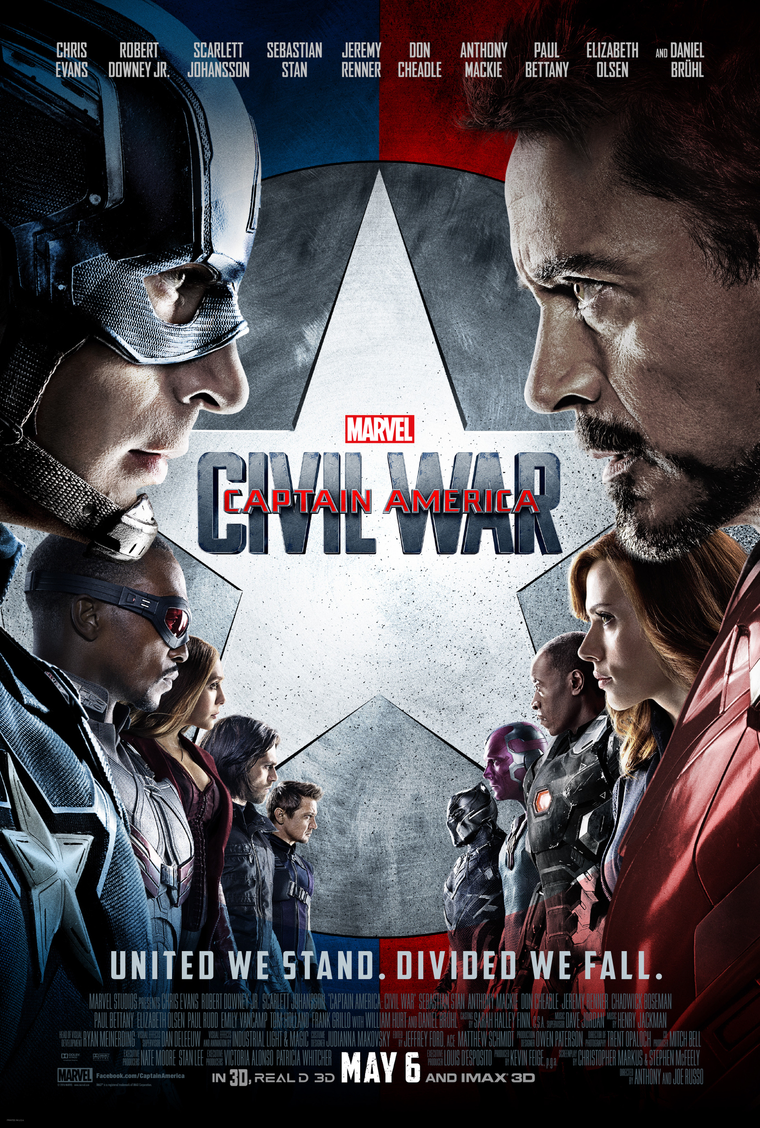

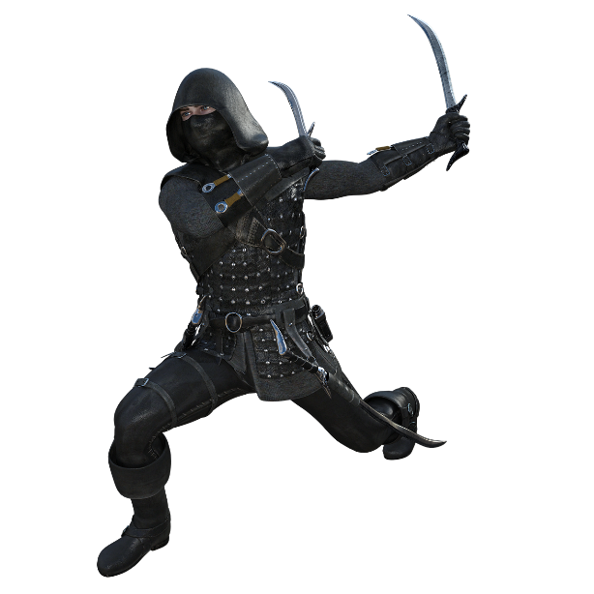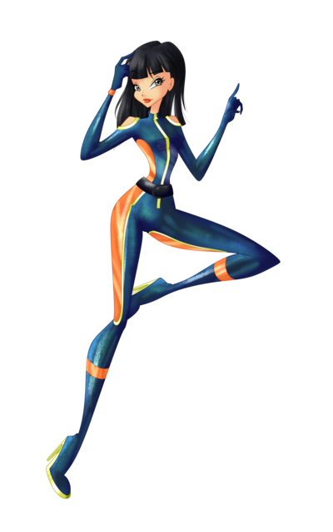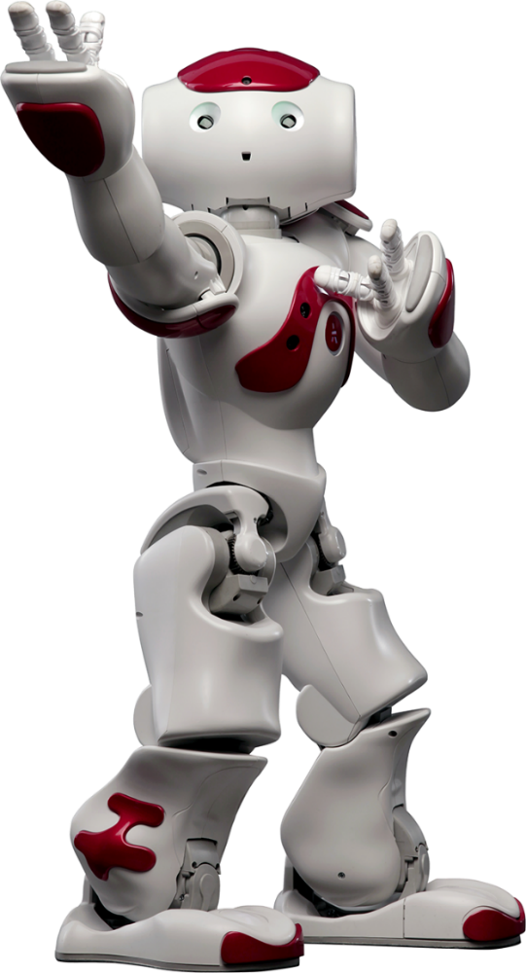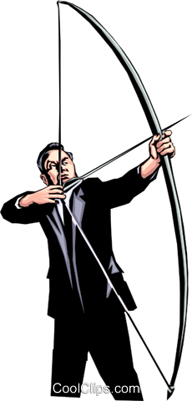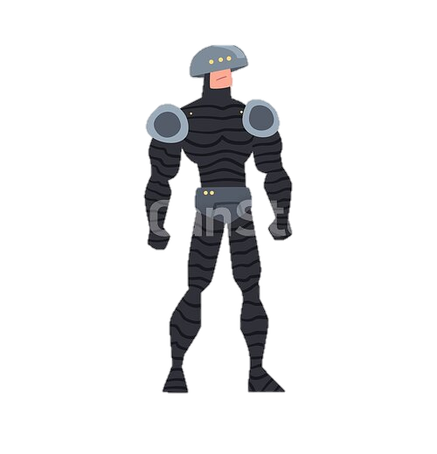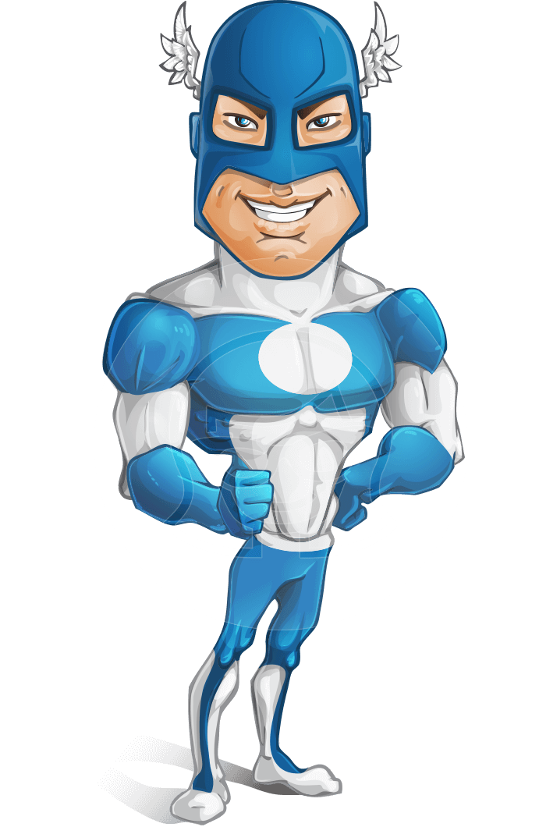

SEBASTIAN

STAN

JEREMY

RENNER

DON

CHEADLE

ANTHONY

MACKIE

PAUL

BETTANY

DANIEL

BRUHL

SCARLETT

JOHANSSON

ROBERT

DOWNEY JR.

CHRIS

EVANS

UNITED WE STAND. DIVIDED WE FALL.

CIVIL WAR

Marvel

CAPTAIN AMERICA